Supplementary Information for
Global agreement masks regional divergence in soil respiration
Xiaohua Ren^{1,2,†}, Jinshi Jian^{2, †}, Pan Li^{1,3, *}, Yuning Gu², Li Zhang⁴, Zhifeng Yan^{1,3}, Renmin Yang^{1,3}, Honglin He⁴, Zhongen Niu⁵, Rong Ge⁶, Yu Wu^{1,3}, Fujun Yue^{1,3}, Guirui Yu⁴, Congqiang Liu^{1,3}, Stephen Sitch⁷, Rodrigo Vargas⁸, Ben Bond-Lamberty⁹

¹ Institute of Surface-Earth System Science, School of Earth System Science, Tianjin University, Tianjin, China
² State Key Laboratory of Soil Erosion and Dryland Farming on the Loess Plateau, Northwest A&F University, Yangling 712100, China
³ Tianjin Bohai Rim Coastal Earth Critical Zone National Observation and Research Station, Tianjin University, Tianjin, China
⁴ Institute of Geographic Sciences and Natural Resources Research, Chinese Academy of Sciences, Beijing, China
⁵ College of Hydraulic and Civil Engineering, Ludong University, Yantai 264025, China
⁶ Institute of Natural Resources and Environmental Audits, School of Government Audit, Nanjing Audit University, Nanjing, China
⁷ Faculty of Environment, Science and Economy, University of Exeter, Exeter EX4 4QF, United Kingdom
⁸ School of Life Sciences, Arizona State University, Tempe, AZ, USA
⁹ Pacific Northwest National Laboratory, Joint Global Change Research Institute, College Park, MD, USA

† These authors contributed equally: Xiaohua Ren, Jinshi Jian.
* Correspondence: Pan Li, pan_li@tju.edu.cn.

Table S1. Summary of historical global annual soil respiration (Rs) estimates based on data-driven models (DDMs). The 10 gridded Rs products used for this study analyses are highlighted in bold black.
ID | Study | Rs（Pg C /yr） | Method | Study Year | Temporal resolution | Spatial resolution | Drivers
1 | Schlesinger (1997)¹ | 75.0 | Carbon balance |  | Annual |  | Climate
2 | Raich and Schlesinger (1992)² | 68.0 | Area × Mean |  | Annual |  | Climate+Soil+Vegetation
3 | Raich and Potter (1995)³ | 76.5 | Semi-empirical model |  | Monthly | 0.5° | Climate
4 | Peng and Apps (2000)⁴ | 69.0 | Semi-empirical model |  | Annual | 0.5° | Climate
5 | Raich et al. (2002)⁵ | 80.4 | Semi-empirical model | 1980-1994 | Monthly | 0.5° | Climate
6 | Bond-Lamberty and Thomson (2010)⁶ | 98.0 | Linear model | 2008 | Annual |  | Climate+Vegetation
7 | Hashimoto (2012)⁷ | 78.0 | Semi-empirical model | 1980-2009 | Monthly | 0.5° | Climate
8 | Chen et al. (2013)⁸ | 94.4 | Semi-empirical model | 1970-2008 | Annual | 0.5° | Climate+Soil
9 | Hashimoto et al. (2015)⁹ | 91.0 | Semi-empirical model | 1965-2012 | Monthly | 0.5° | Climate
10 | Oertel et al. (2016)¹⁰ | 95.0 | Area × Mean |  | Annual
11 | Xu and Shang (2016)¹¹ | 94.3 | Area × Mean | 2000–2012 | Annual
12 | Adachi et al. (2017)¹² | 94.8 | Semi-empirical model | 2001 | Daily | 4km | Climate+Soil
13 | Adachi et al. (2017)¹² | 93.8 | Semi-empirical model | 2009 | Daily | 4km | Climate
14 | Zhao et al. (2017)¹³ | 93.3 | Machine learning | 1960-2012 | Annual | ~9 km | Climate+Soil+Vegetation
15 | Hursh et al. (2017)¹⁴ | 93.9 | Statistical model | 2014 | Annual |  | Climate+Soil+Vegetation
16 | Hursh et al. (2017)¹⁴ | 80.3 | Semi-empirical model | 2014 | Annual |  | Climate+Soil+Vegetation
17 | Hursh et al. (2017)¹⁴ | 108.6 | Semi-empirical model | 2014 | Annual |  | Climate+Soil+Vegetation
18 | Jian et al. (2018)¹⁵ | 78.8 | Machine learning | 1961-2014 | Monthly | 0.5° | Climate+Vegetation
19 | Jian et al. (2018)¹⁵ | 88.2 | Machine learning | 1961-2014 | Annual | 0.5° | Climate+Vegetation
20 | Jian et al. (2018)¹⁵ | 70.9 | Semi-empirical model | 1961-2014 | Monthly | 0.5° | Climate+Vegetation
21 | Jian et al. (2018)¹⁵ | 66.6 | Semi-empirical model | 1961-2014 | Monthly | 0.5° | Climate+Vegetation
22 | Jian et al. (2018)¹⁵ | 75.8 | Semi-empirical model | 1961-2014 | Monthly | 0.5° | Climate+Vegetation
23 | Jian et al. (2018)¹⁵ | 71.4 | Semi-empirical model | 1961-2014 | Monthly | 0.5° | Climate+Vegetation
24 | Jian et al. (2018)¹⁵ | 81.0 | Semi-empirical model | 1961-2014 | Monthly | 0.5° | Climate+Vegetation
25 | Jian et al. (2018)¹⁵ | 76.2 | Semi-empirical model | 1961-2014 | Monthly | 0.5° | Climate+Vegetation
26 | Jian et al. (2018)¹⁵ | 74.4 | Semi-empirical model | 1961-2014 | Daily | 0.5° | Climate+Vegetation
27 | Jian et al. (2018)¹⁵ | 93.3 | Semi-empirical model | 1961-2014 | Monthly | 0.5° | Climate+Vegetation
28 | Jian et al. (2018)¹⁵ | 88.6 | Semi-empirical model | 1961-2014 | Monthly | 0.5° | Climate+Vegetation
29 | Jian et al. (2018)¹⁵ | 100.7 | Semi-empirical model | 1961-2014 | Annual | 0.5° | Climate+Vegetation
30 | Jian et al. (2018)¹⁵ | 97.0 | Semi-empirical model | 1961-2014 | Annual | 0.5° | Climate+Vegetation
31 | Jian et al. (2018)¹⁶ | 78.3 | single model | 1961-2014 | Monthly | 0.5° | Climate
32 | Jian et al. (2018)¹⁶ | 72.6 | climate-specific model | 1961-2014 | Monthly | 0.5° | Climate
33 | Warner et al. (2020)¹⁷ | 87.9 | Machine learning | 1961-2011 | Annual | 1km | Climate+Vegetation
34 | Tang et al. (2019; 2020)^{18,19} | 101.0 | Machine learning | 1980-2012/2016 | Annual | 0.5° | Climate+Soil
35 | Huang et al. (2020)²⁰ | 72.6 | Machine learning & Semi-empirical model | 2000-2014 | Annual | 1km | Climate+Vegetation
36 | Lei et al. (2021)²¹ | 85.6 | Linear model | 1987–1998 | Annual |  | Climate
37 | Lei et al. (2021)²¹ | 87.5 | Linear model | 1999-2016 | Annual |  | Climate
38 | Lu et al. (2021)²² | 85.5 | Machine learning | 1982–2012 | Annual | 0.5° | Climate+Vegetation
29 | Stell et al. (2021)²³ | 88.6 | Machine learning |  | Annual | 1km | Climate+Vegetation
40 | Stell et al. (2021)²³ | 96.5 | Machine learning |  | Annual | 1km | Climate+Vegetation
41 | Jian et al. (2022)²⁴ | 68.0 | Carbon balance |  | Annual | 0.5°
42 | Jian et al. (2022)²⁴ | 93.0 | Machine learning |  | Monthly | 0.5° | Climate+Vegetation
43 | Jiang et al. (2024)²⁵ | 95.1 | Machine learning | 2020 | Monthly | 0.5°
44 | Jiang et al. (2024)²⁵ | 97.8 | Machine learning | 2020 | Monthly | 0.5°
45 | Jiang et al. (2024)²⁵ | 85.9 | Machine learning | 2020 | Monthly | 0.5°
43 | Jiang et al. (2024)²⁵ | 106.0 | Machine learning | 2020 | Monthly | 0.5° | Climate+Soil+Vegetation
47 | Jiang et al. (2024)²⁵ | 108.7 | Machine learning | 2020 | Monthly | 0.5° | Climate+Soil+Vegetation
48 | Laffitte et al. (2025)²⁶ | 79.4 | Machine learning | 1982-2018 | Monthly | 0.05° | Climate+Vegetation
49 | Laffitte et al. (2025)²⁶ | 78.3 | Machine learning | 1982-2018 | Annual | 0.05° | Climate+Vegetation
50 | Jiang et al. (2025)²⁷ | 85.1 | Machine learning |  | Monthly | 0.5° | Climate+Vegetation
51 | Jiang et al. (2025)²⁷ | 88.4 | Machine learning |  | Monthly | 0.5° | Climate+Vegetation

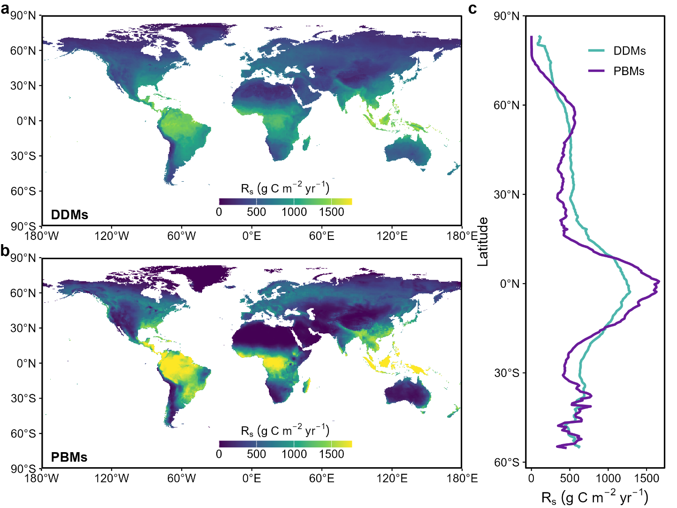
Figure S1. Difference in the spatial distribution of global soil respiration (Rs) is estimated by data-driven models (DDMs) and process-based models (PBMs).
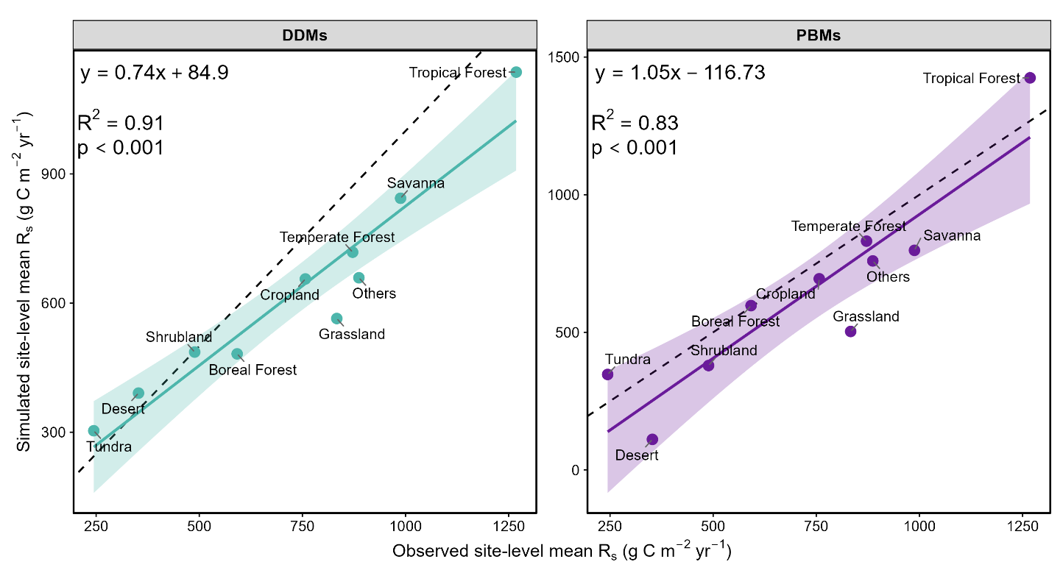
Figure S2. Comparison of biome-level mean soil respiration (Rs) between SRDB-V5 and model estimates. Model outputs from data-driven models (DDMs) and process-based models (PBMs) were extracted at the SRDB-V5 site locations and averaged across sampling sites within each biome.
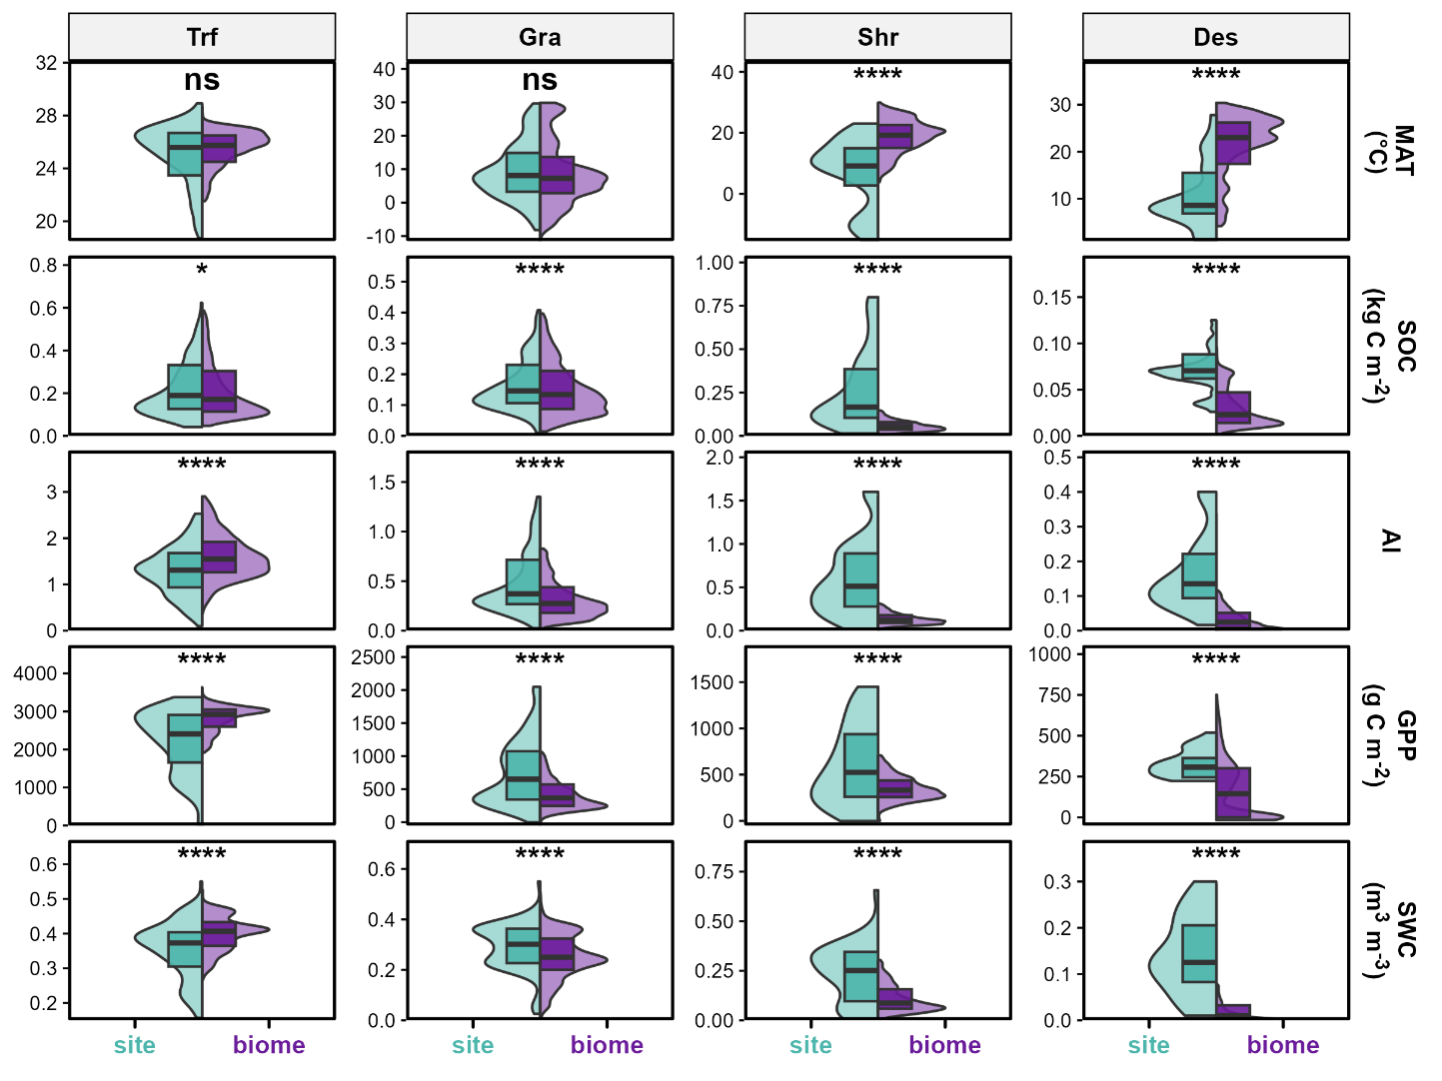
Figure S3. Representativeness of observation sites relative to biome-wide conditions for environmental drivers and modelled soil respiration (Rs) across four biomes. Split violin plots compare the distribution of each variable at SRDB-V5 measurement locations (site, left half, teal) with the distribution across all grid cells of the corresponding biome (biome, right half, purple). Half violins show kernel density estimates for site and biome distributions, truncated at the box-plot whisker ends. Boxes indicate the 25th, 50th (median) and 75th percentiles, with whiskers extending to the most extreme values within 1.5 × the interquartile range (IQR); values beyond the whiskers are not shown. Asterisks indicate significance from two-sided Wilcoxon rank-sum tests comparing site and biome distributions (****p < 0.0001, ***p < 0.001, **p < 0.01, *p < 0.05; ns, p > 0.05). Biome abbreviations are defined in Fig. 1.
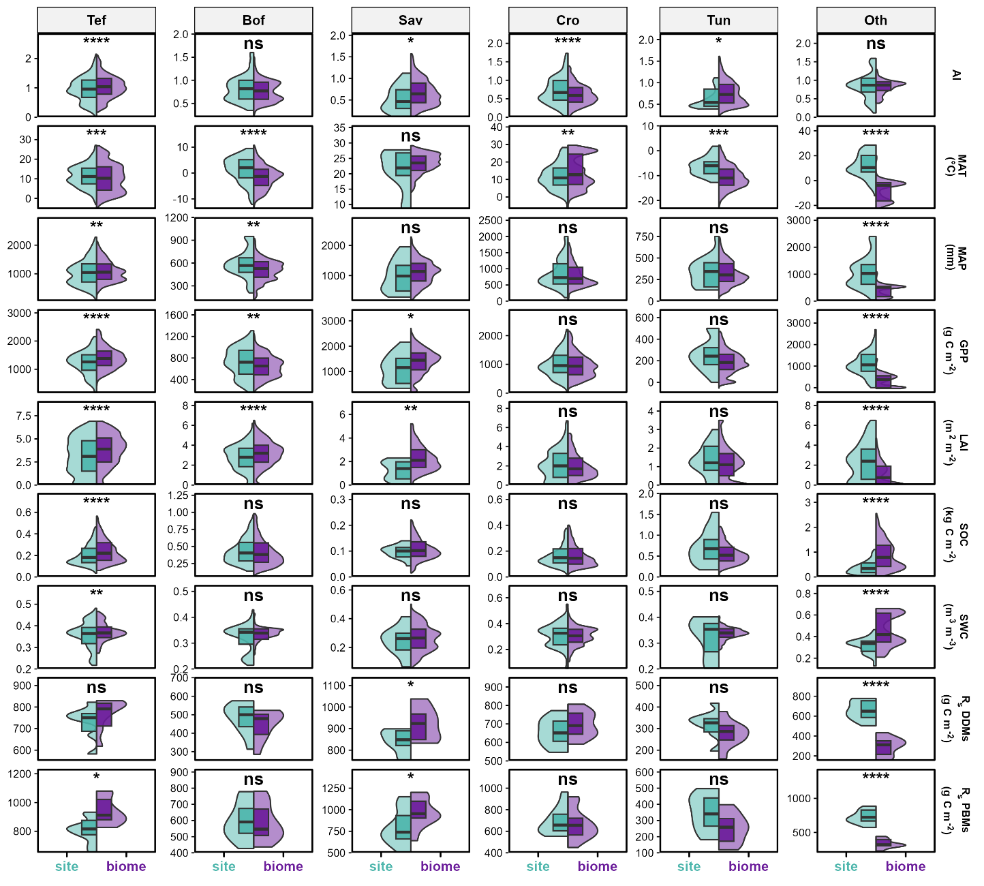
Figure S4. Representativeness of observation sites relative to biome-wide conditions for environmental drivers and modelled soil respiration (Rs) across four biomes. Split violin plots compare the distribution of each variable at SRDB-V5 measurement locations (site, left half, teal) with the distribution across all grid cells of the corresponding biome (biome, right half, purple). Half violins show kernel density estimates for site and biome distributions, truncated at the box-plot whisker ends. Boxes indicate the 25th, 50th (median) and 75th percentiles, with whiskers extending to the most extreme values within 1.5 × the interquartile range (IQR); values beyond the whiskers are not shown. Asterisks indicate significance from two-sided Wilcoxon rank-sum tests comparing site and biome distributions (****p < 0.0001, ***p < 0.001, **p < 0.01, *p < 0.05; ns, p > 0.05). Biome abbreviations are defined in Fig. 1.
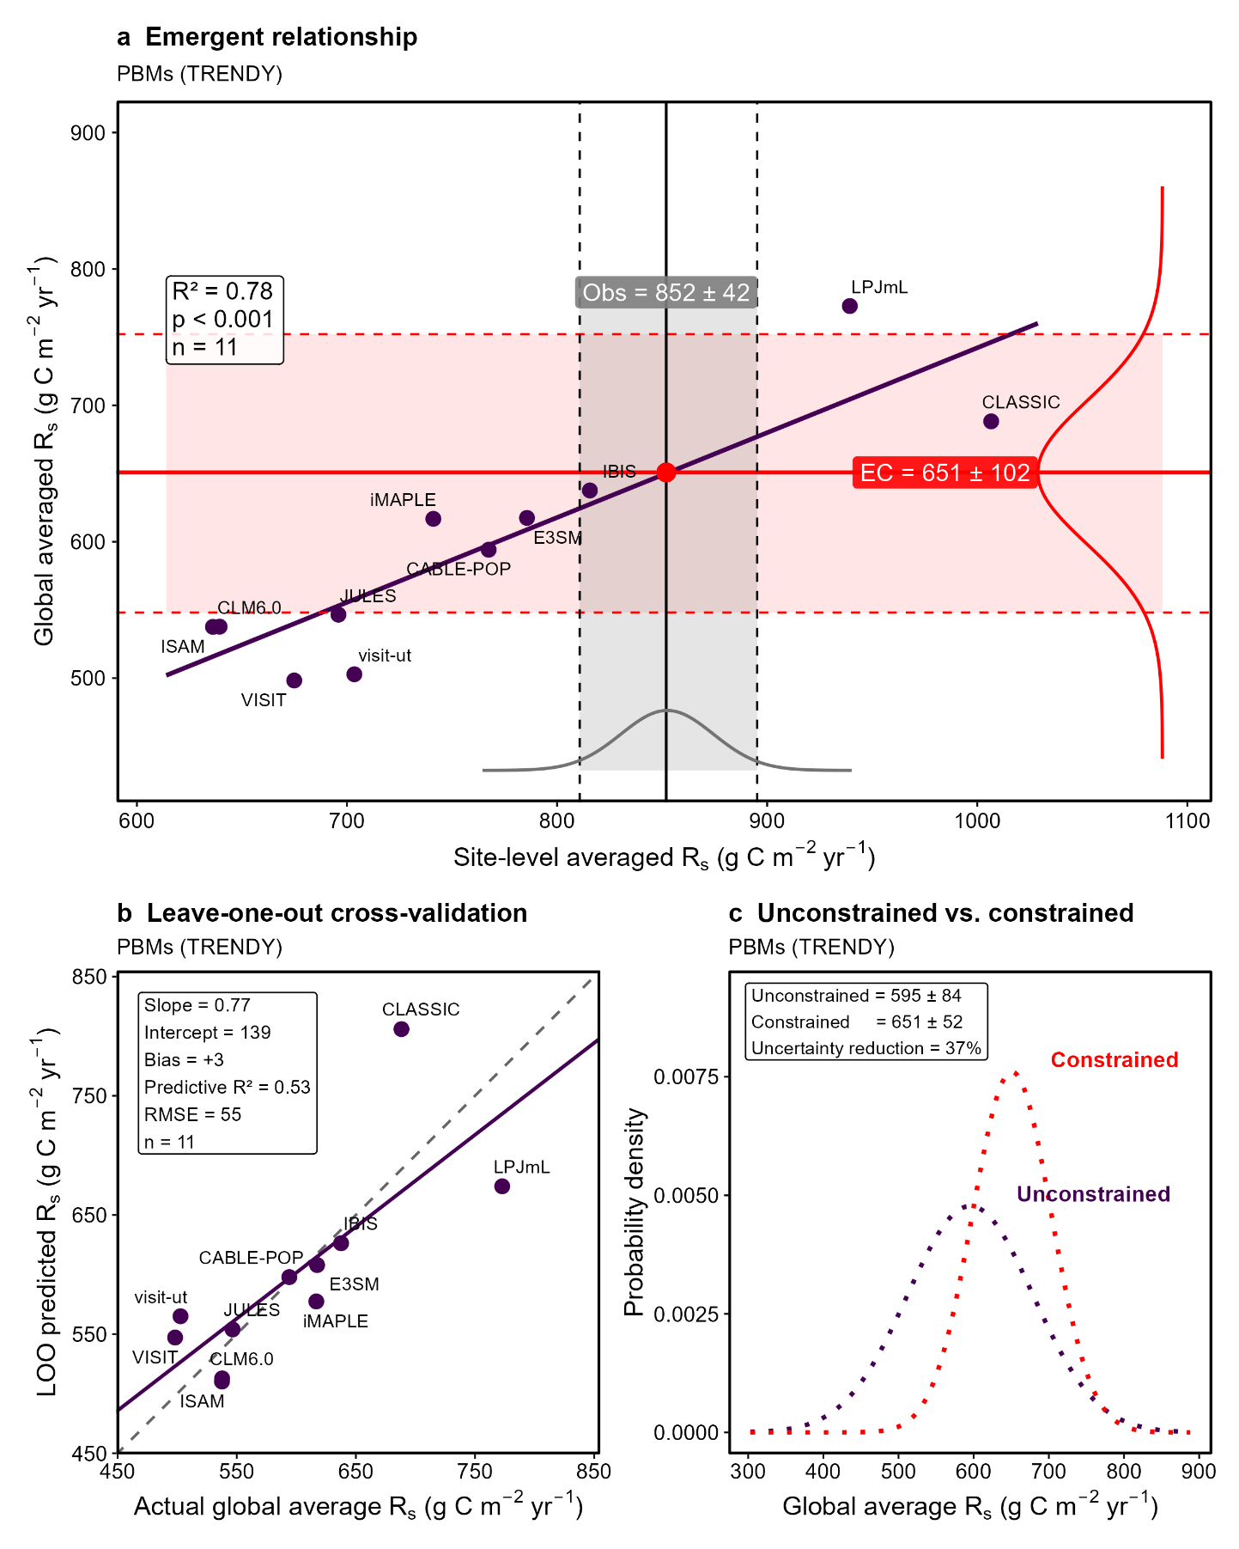
Figure S5. Emergent constraint on the global average soil respiration (Rs) of process-based models (PBMs). (a) Global average Rs versus site-level average Rs, the latter evaluated at the SRDB-V5 observation locations, across the PBMs (points, n = 11). The solid line is the ordinary least squares regression across the models. The vertical dashed line marks the observational constraint given by the SRDB-V5 site-level mean. The red diamond and the horizontal solid line mark the constrained estimate of global average Rs obtained by mapping the observation through the regression, and the horizontal dashed lines mark its uncertainty range (mean ± 1 s.d.). The inset reports the coefficient of determination, the regression p value, and the number of models. (b) Probability density of global average Rs before (unconstrained) and after (constrained) the emergent constraint. The unconstrained density is defined by the mean and standard deviation across the model ensemble, and the constrained density was obtained by propagating the observational uncertainty and the regression uncertainty through the intermodel relationship in (a). The inset reports the mean ± 1 s.d. of each distribution and the relative reduction in the uncertainty range.
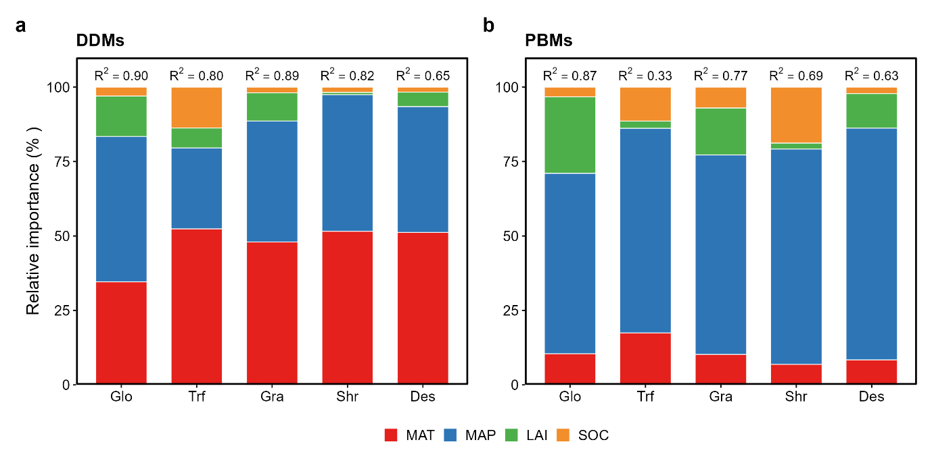
Figure S6. Relative importance of MAT, MAP, LAI and SOC in explaining soil respiration (Rs) in (a) data-driven models (DDMs) and (b) process-based models (PBMs). Importance is the absolute standardized ridge-regression coefficient of each predictor as a percentage of the sum across the four predictors (values sum to 100% per bar); R² above each bar is the variance in Rs explained by the model. Glo represents the global scale, and biome abbreviations are defined in Fig. 1.
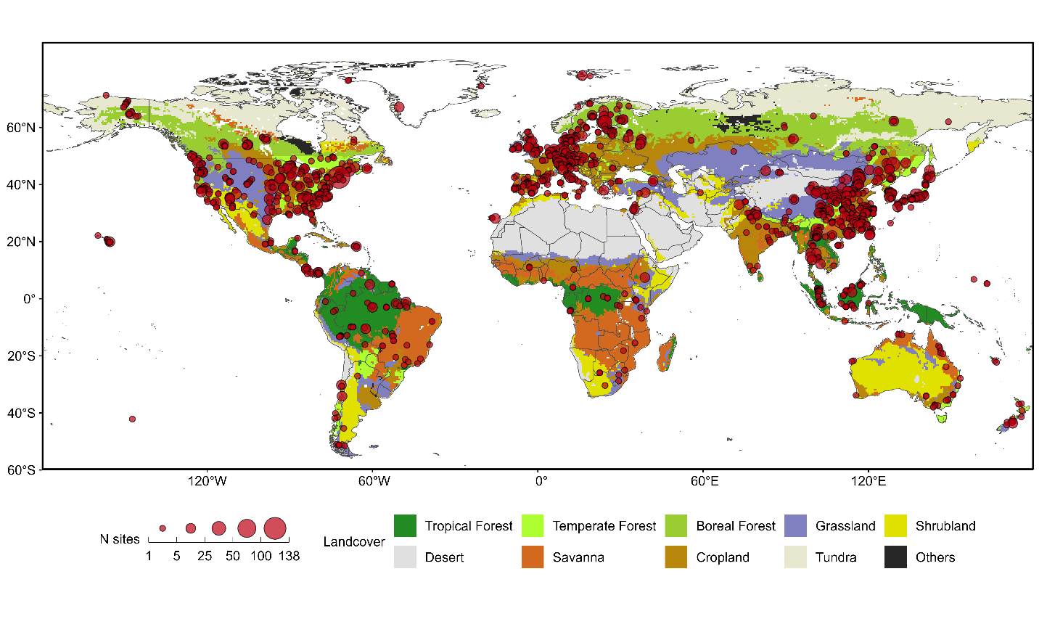
Figure S7. Global distribution of soil respiration (Rs) observations across biomes. Global distribution of Rs observation sites included in the analysis (red circles) overlaid on the spatial distribution of the ten biome categories (background colours). Circle size indicates the number of soil respiration observation sites within each grid cell (N sites).
Table S2. Detailed information of the TRENDY v13 Dynamic Global Vegetation Models used in this study.
Model | Scenario | Spatial resolution | Reference
CABLE-POP | S3 | 1° | Haverd et al. (2018)²⁸
CLASSIC | S3 | 1° | Melton et al. (2020)²⁹
CLM6.0 | S3 | ~1.25° | Lawrence et al. (2019)³⁰
E3SM | S3 | ~1.25° | Yang et al. (2023)³¹
IBIS | S3 | 0.5° | Xia et al. (2024)³²
ISAM | S3 | 0.5° | Shu et al. (2020)³³
JULES | S3 | 0.5° | Wiltshire et al. (2021)³⁴
LPJml | S3 | 0.5° | Schaphoff et al. (2018)³⁵
visit-ut | S3 | 0.5° | Ito (2019)³⁶
VISIT | S3 | 0.5° | Kato et al. (2013)³⁷
iMAPLE | S3 | 1° | Yue et al. (2024)³⁸

Table S3. Environmental variables used in this study and their data sources.
Variable | Description | Unit | Spatial resolution | Data source | Study
MAT | mean annual temperature | °C | 0.5° | CRU TS v4.04 | Harris et al. (2020)³⁹
MAP | mean annual precipitation | mm yr⁻¹ | 0.5° | CRU TS v4.04 | Harris et al. (2020)³⁹
LAI | leaf area index | m² m⁻² | 1km | MODIS LAI | Yuan et al. (2011)⁴⁰
SOC | soil organic carbon content | kg C m⁻² | 250 m | SoilGrids 2.0 | Poggio et al. (2021)⁴¹
GPP | gross primary productivity | g C m⁻² yr⁻¹ | 0.5° (RS+METEO) | FLUXCOM Carbon Fluxes (Annual Ensemble) | Tramontana et al. (2016) ⁴²; Jung et al. (2020)⁴³
AI | aridity index |  | 30 arc-seconds | Global Aridity Index and Potential Evapotranspiration Database v3 | Zomer et al. (2022)⁴⁴
SWC | soil water content | m³ m⁻³ | 0.25° | ERA5 reanalysis | Hersbach et al. (2020)⁴⁵

References
1. Schlesinger, W. H. Carbon balance in terrestrial detritus. Annu. Rev. Ecol. Syst. 8, 51–81 (1977).
2. Raich, J. W. & Schlesinger, W. H. The global carbon dioxide flux in soil respiration and its relationship to vegetation and climate. Tellus B 44, 81–99 (1992).
3. Raich, J. W. & Potter, C. S. Global patterns of carbon dioxide emissions from soils. Global Biogeochem. Cycles 9, 23–36 (1995).
4. Chang-hui, P. & Michael J., A. Simulating global soil-CO₂flux and its response to climate change. J. Environ. Sci. 257–265 (2000).
5. Raich, J. W., Potter, C. S. & Bhagawati, D. Interannual variability in global soil respiration, 1980–94. Global Change Biol. 8, 800–812 (2002).
6. Bond-Lamberty, B. & Thomson, A. Temperature-associated increases in the global soil respiration record. Nature 464, 579–582 (2010).
7. Hashimoto, S. A new estimation of global soil greenhouse gas fluxes using a simple data-oriented model. PLOS One 7, e41962 (2012).
8. Chen, S. et al. A new estimate of global soil respiration from 1970 to 2008. Chin. Sci. Bull. 58, 4153–4160 (2013).
9. Hashimoto, S. et al. Global spatiotemporal distribution of soil respiration modeled using a global database. Biogeosciences 12, 4121–4132 (2015).
10. Oertel, C., Matschullat, J., Zurba, K., Zimmermann, F. & Erasmi, S. Greenhouse gas emissions from soils—a review. Geochemistry 76, 327–352 (2016).
11. Xu, M. & Shang, H. Contribution of soil respiration to the global carbon equation. J. Plant Physiol. 203, 16–28 (2016).
12. Adachi, M., Ito, A., Yonemura, S. & Takeuchi, W. Estimation of global soil respiration by accounting for land-use changes derived from remote sensing data. J. Environ. Manage. 200, 97–104 (2017).
13. Zhao, Z. et al. Model prediction of biome-specific global soil respiration from 1960 to 2012. Earth’s Future 5, 715–729 (2017).
14. Hursh, A. et al. The sensitivity of soil respiration to soil temperature, moisture, and carbon supply at the global scale. Global Change Biol. 23, 2090–2103 (2017).
15. Jian, J., Steele, M. K., Thomas, R. Q., Day, S. D. & Hodges, S. C. Constraining estimates of global soil respiration by quantifying sources of variability. Global Change Biol. 24, 4143–4159 (2018).
16. Jian, J., Steele, M. K., Day, S. D. & Thomas, R. Q. Future global soil respiration rates will swell despite regional decreases in temperature sensitivity caused by rising temperature. Earth’s Future 6, 1539–1554 (2018).
17. Warner, D. L., Bond-Lamberty, B., Jian, J., Stell, E. & Vargas, R. Spatial predictions and associated uncertainty of annual soil respiration at the global scale. Global Biogeochem. Cycles 33, 1733–1745 (2019).
18. Tang, X. et al. Global variability in belowground autotrophic respiration in terrestrial ecosystems. Earth Syst. Sci. Data 11, 1839–1852 (2019).
19. Tang, X. et al. A decreasing carbon allocation to belowground autotrophic respiration in global forest ecosystems. Sci. Total Environ. 798, 149273 (2021).
20. Huang, N. et al. Spatial and temporal variations in global soil respiration and their relationships with climate and land cover. Sci. Adv. 6, eabb8508 (2020).
21. Lei, J. et al. Temporal changes in global soil respiration since 1987. Nat. Commun. 12, 403–412 (2021).
22. Lu, H. et al. Comparing machine learning-derived global estimates of soil respiration and its components with those from terrestrial ecosystem models. Environ. Res. Lett. 16, 054048 (2021).
23. Stell, E., Warner, D., Jian, J., Bond-Lamberty, B. & Vargas, R. Spatial biases of information influence global estimates of soil respiration: how can we improve global predictions? Global Change Biol. 27, 3923–3938 (2021).
24. Jian, J. et al. Historically inconsistent productivity and respiration fluxes in the global terrestrial carbon cycle. Nat. Commun. 13, 1733 (2022).
25. Jiang, J. et al. Global soil respiration predictions with associated uncertainties from different spatio-temporal data subsets. Ecol. Inf. 82, 102777 (2024).
26. Laffitte, B. et al. Timescale matters: finer temporal resolution influences driver contributions to global soil respiration. Global Change Biol. 31, e70118 (2025).
27. Jiang, J., Feng, L., Hu, J. & Zhu, C. Spatial non-uniformity in the distribution of global soil respiration observation data: implications for model predictions. Agric. For. Meteorol. 372, 110734 (2025).
28. Haverd, V. et al. A new version of the CABLE land surface model (subversion revision r4601) incorporating land use and land cover change, woody vegetation demography, and a novel optimisation-based approach to plant coordination of photosynthesis. Geosci. Model Dev. 11, 2995–3026 (2018).
29. Melton, J. R. et al. CLASSIC v1.0: The open-source community successor to the canadian land surface scheme (CLASS) and the canadian terrestrial ecosystem model (CTEM) – part 1: model framework and site-level performance. Geosci. Model Dev. 13, 2825–2850 (2020).
30. Lawrence, D. M. et al. The community land model version 5: description of new features, benchmarking, and impact of forcing uncertainty. JAMES 11, 4245–4287 (2019).
31. Yang, X., Thornton, P., Ricciuto, D., Wang, Y. & Hoffman, F. Global evaluation of terrestrial biogeochemistry in the energy exascale earth system model (E3SM) and the role of the phosphorus cycle in the historical terrestrial carbon balance. Biogeosciences 20, 2813–2836 (2023).
32. Xia, X. et al. The carbon budget of China: 1980–2021. Sci. Bull. 69, 114–124 (2024).
33. Shu, S., Jain, A. K., Koven, C. D. & Mishra, U. Estimation of permafrost SOC stock and turnover time using a land surface model with vertical heterogeneity of permafrost soils. Global Biogeochem. Cycles 34, e2020GB006585 (2020).
34. Wiltshire, A. J. et al. JULES-CN: A coupled terrestrial carbon–nitrogen scheme (JULES vn5.1). Geosci. Model Dev. 14, 2161–2186 (2021).
35. Schaphoff, S. et al. LPJmL4 – a dynamic global vegetation model with managed land – part 1: Model description. Geosci. Model Dev. 11, 1343–1375 (2018).
36. Ito, A. Disequilibrium of terrestrial ecosystem CO₂ budget caused by disturbance-induced emissions and non-CO₂ carbon export flows: A global model assessment. Earth Syst. Dyn. 10, 685–709 (2019).
37. Kato, E., Kinoshita, T., Ito, A., Kawamiya, M. & Yamagata, Y. Evaluation of spatially explicit emission scenario of land-use change and biomass burning using a process-based biogeochemical model. J. Land Use Sci. 8, 104–122 (2013).
38. Yue, X. et al. Development and evaluation of the interactive model for air pollution and land ecosystems (iMAPLE) version 1.0. Geosci. Model Dev. 17, 4621–4642 (2024).
39. Harris, I., Osborn, T. J., Jones, P. & Lister, D. Version 4 of the CRU TS monthly high-resolution gridded multivariate climate dataset. Sci. Data 7, 109 (2020).
40. Yuan, H., Dai, Y., Xiao, Z., Ji, D. & Shangguan, W. Reprocessing the MODIS leaf area index products for land surface and climate modelling. Remote Sens. Environ. 115, 1171–1187 (2011).
41. Poggio, L. et al. SoilGrids 2.0: producing soil information for the globe with quantified spatial uncertainty. Soil 7, 217–240 (2021).
42. Tramontana, G. et al. Predicting carbon dioxide and energy fluxes across global FLUXNET sites withregression algorithms. Biogeosciences 13, 4291–4313 (2016).
43. Jung, M. et al. Scaling carbon fluxes from eddy covariance sites to globe: synthesis and evaluation of the FLUXCOM approach. Biogeosciences 17, 1343–1365 (2020).
44. Zomer, R. J., Xu, J. & Trabucco, A. Version 3 of the global aridity index and potential evapotranspiration database. Sci. Data 9, 409–423 (2022).
45. Hersbach, H. et al. The ERA5 global reanalysis. Q. J. R. Meteorolog. Soc. 146, 1999–2049 (2020).

